**Questions for Students**

1. Are you satisfied with the existing timesheet process?

2. If NO please state why?

3. What are your expectations from this proposed web-based timesheet management system?

4. The homepage is displayed here which has a deadline date and three options to pursue further into the website. The deadline date will be automatically set and updated over time. Any suggestions to improve this?

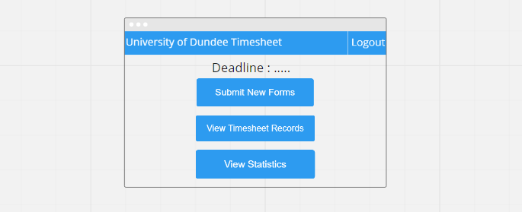

5. Here two options are designed to view timesheet records. In option 1 the complete records of all the timesheets submitted will be displayed in the table without any filtering option in the page. While in option 2 the page will consist of filtering options using dropdown list for module, role and status which will retrieve the specific timesheet. The option 2 picture shows an example of filtering using status dropdown list. In both the options the user can click the link of any records and this will load a page with the student details. Please choose one of the options.

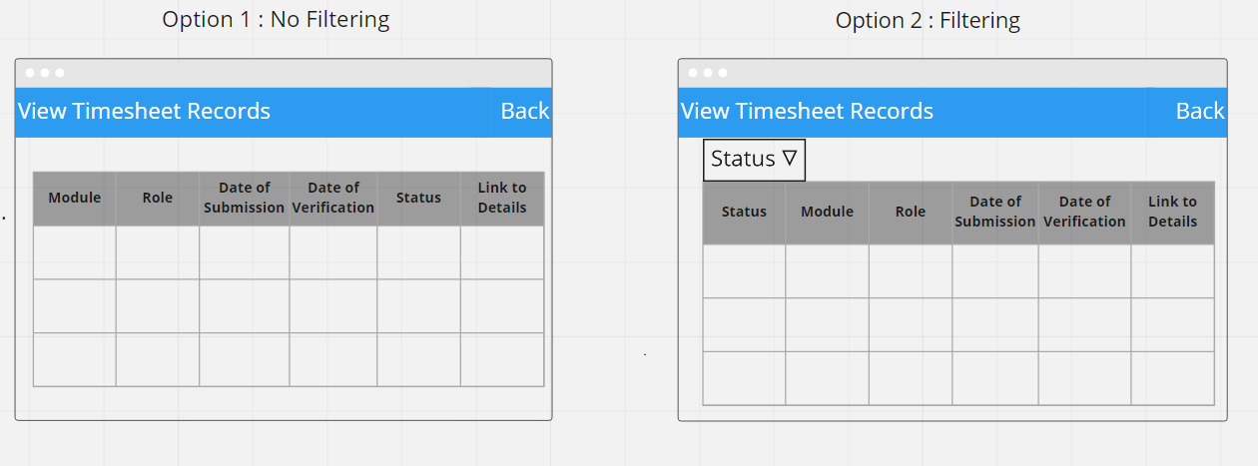

6. Justify your answer for the previous question.

7. State any additional ideas related to view timesheet records option.

8. Here two options are designed to view statistics. Both options will display the total number of hours worked in each week of the whole month in a bar chart. In option 1 there is no filtering option in the page. While in option 2 the page will consist of filtering options such as module, role and timeline which will display the total number of hours worked for the specific options selected. Please choose one of the options.

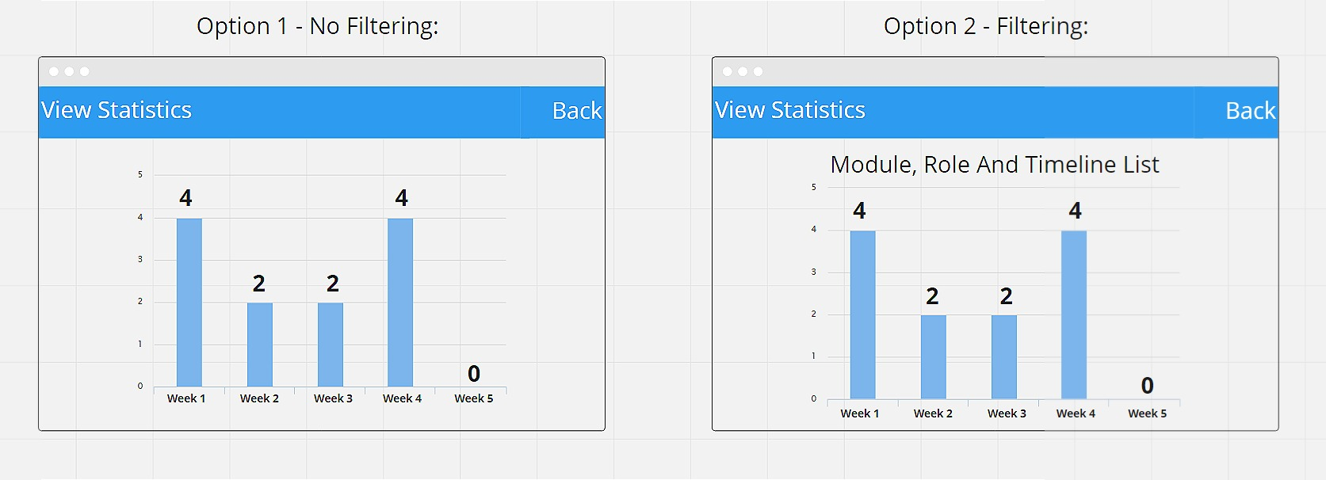

9. Justify your answer for the previous question.

10. State any additional ideas related to view statistics option.

11. Here two options are designed to submit new timesheet forms. In option 1 the user has to manually fill the table present in the page. While in option 2 the page will consist of dropdown lists which the user can use to select a date and enter the number of hours the user has worked on that day. The option 2 page will automatically calculate the total hours based on the user's input and the user can also click on add more hours to select another day and enter the number of hours the user has worked on that day. Please choose one of the options.

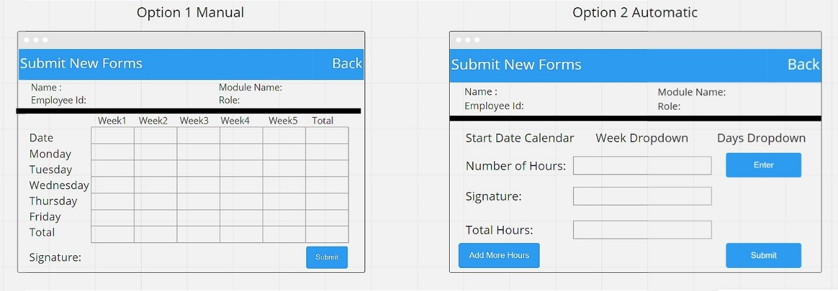

12. Justify your answer for the previous question.

13. For option 2 do you want a generate data button which will show all the user entries in a table format? Explain your answer.

14. State any additional ideas related to submit new forms option.